PID Controller Documentation

The figure bellows demonstrates a typical closed loop system for which a PID controller is modelled.

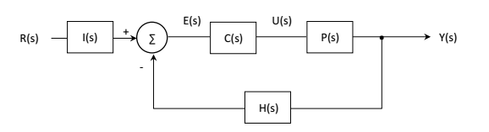

In PID theory, all transfer functions (e.g. R(s) are a function of s as per the Laplace domain).

R(s), the reference signal, is the input signal to the system. The difference between the output signal (Y(s)) and the reference signal should be minimized, by the closed loop system.

I(s), the input filter transfer function, converts the input signal to a usable form for the controller.

C(s), the controller transfer function, is the brain of the system, responsible for minimizing error between the reference and output. PID (proportional plus integral plus derivative controllers) are a type of controller transfer function. For PID, C(s) is equal to the expression below:

$$C\left(s\right)=\frac{KdS^{2}+KpS+Ki}{s} (1)$$

E(s), error signal, is the difference between the output of the input filter function and the feedback transfer function H(s).

U(s), controller output signal, is the signal that the controller calculates and applies to the plant (in our case, the rotating jig and its associated physical terms like inertia).

**Plant Transfer function P(s)**

The plant transfer function is derived using one of two techniques. The first technique, ‘First Principles Techniques’ can be used when enough information is known about the system. For a mechanical system, a free body diagram of the plant is created, to which Newton’s Second Laws of motion are applied. For the rotating jig system, rotational motion is the focus:

$$\sum{Τ=Ia} (2)$$

The second approach, ‘Transient and Steady-State Response Analysis’ is used when scarce amounts of information is known about the plant. A known signal is applied to the plant, such as a step function of an arbitrary voltage value, and the steady – state response of the plant is analyzed.

**Rotating Jig Plant Specs:**

It is essential for the controller function, more specifically determining the gain values for the controller in equation 1, to determine the performance specifications of the system. Since the jig will rotate for 30 – 60 minutes, rise time will be ignored. Furthermore, maximum overshoot is not of utmost importance, either. For this reason, maximum percent overshoot will be limited to 25% for a step input. Lastly, zero steady-state error for a step input is also required. In other words, the actual speed of the system minus the desired speed of the system will equal zero.

The specifications of the system can be summarized as the following:

1. Maximum percent overshoot < 25% for a step input (derivative controller)
2. Steady-state error = 0 for a step input (Integral controller)

For these specifications, a

**Modelling Each Element:**

1. **Stepper Motor System:**

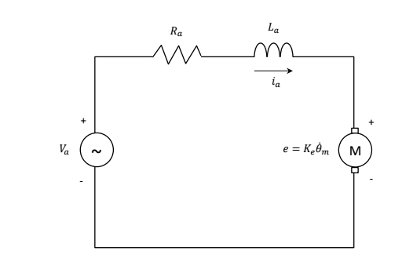

Using KVL on the motor’s electric armature results in:

$$0=Ri+L\frac{di}{dt}+Ke\dot{ϑ}-V (3)$$

According the stepper motor’s datasheet (pololu.com/product/1477), the Nema 23 stepper has the following specs:

R = 8.6 Ohms

I

|  |  |
| --- | --- |
| Spec | Value |
| R | 8.6 Ohms |
| i | 0.06 A |
| V | 12 V |
| L | 0.014 H |
| Ke | ?? |

1. **DC Motor System:**

|  |  |
| --- | --- |
| Spec | Value |
| R | 8.6 Ohms |
| i | 0.06 A |
| V | 12 V |
| L | 0.014 H |
| Ke | ?? |